HOW TO MAKE A GOOD PRESENTATION

Public speaking can be and usually is very stressful. It does not matter whether you speak at conferences or give an internal presentation to your colleagues. A good presentation always requires discipline, practice and perfect preparation as well as knowledge what you need to know and what you want to say.
Thankfully there are some useful pieces of advice, tips and tricks that should help you on your way of becoming a good speaker. We all know that diligence and good ideas are essential for us to succeed either at school or at work. But the ability to formulate your ideas, to express yourself clearly and get your audience (or even your opponents) interested may play just the same or – sometimes – a more important role.
Remember: you will be involved in public speaking during your studies and professional career quite often. Do not panic because the more practice you will have, the more prepared you will be, the more confident you will feel. Still bear in mind that oral communication is a personal skill. It cannot be taught. Only practice or lack of it makes the difference.

Following instructions can help to point the way but everything else is only up to you.
Classic presentation organisation starts with the preparation which is followed by making a presentation and delivering a presentation.

Preparation
(content, time plan, language and visual aids)

A good presentation depends on thorough preparation. You should prepare the logical structure, mark the objectives of the speech and realize the main points. During preparation put down themes and ideas, write notes, sources and points. You must involve things your audience did not know or explain them from a slightly different point of view than is common. You should finalise the whole text at least the day before and practise it before the real thing. While practising, mind not only the content of the presentation, language, time plan and visual aids but also the delivering of your presentation which involves your appearance, voice and body language. Do not forget that you can win or lose even before you start.

Content of the presentation – establish the key message and clear objectives. Content should be relevant and meet the expectations of the audience. Involve your audience and create their interest.
Organise a clear structure, link the different sections so that they may make sense, repeat the key message from the introduction at the end of the speech. The introduction and ending should have the maximum impact.

Time plan (timing) – is very important. You shoud tell your audience how long you are going to speak and you should stick to it. Running out of time can ruin the whole presentation. Better if you keep it short (you should not prepare too much material). The time left can be used for discussion or taking more questions.

The British aristocrat Lord Brabazon once said: "If you cannot say what you have to say in twenty minutes, you should go away and write a book about it".

Language – should be appropriate to the ocassion.You should avoid jargon, complex phrases and formal language. Use short sentences and phrases for dramatic effect, signpost, use rhetorical questions, repeat, summarize, try anecdotes, use analogies and comparisons, use striking adjectives and adverbs, make use of metaphors and quotations, involve your audience – refer to their personal experience.

Robert Darlington recommends the following practise: (see the link at the end of this material)
KISS (Keep it simple, stupid). Don't try to impress with over-complicated terminology. For example: when he was Labour's Shadow Chancellor, Gordon Brown famously praised "neoclassical endogenous growth theory and a symbiotic relationship between investment in people and infrastructure" (1996). In the introduction to his compilation "Speeches That Changed The World", Simon Sebag Montefiore states: "As a rule, simplicity of language marks superb speechmaking".

Visual aids (OHP, PowerPoint, Excel, video, film, flipchart, whiteboard, blackboard, etc.) – use them effectively. Handle aids and equipment professionally (make sure you are able to handle it in advance). Prepare simple and clear messages in big and bold letters. Use colours (avoid yellow and orange). Number slides or transparencies and mark those numbers in your presentation. Be prepared to provide handouts (either at the beginning or at the end, it depends on circumstances).

Delivering a presentation
(appearance, voice, body language)

Appearance – influences the attitude of your audience to you. Be neat and dress appropriately.

Voice – even the best brand new idea can be lost if “how to say“ is not as important as “what to say“. Speak up and articulate clearly, do not hurry, use pauses and repetition, emphasise important words, speed up and slow down, stress auxiliaries, change tone, rhythm, pitch and volume.
Avoid: talking to the display or screen or board, muttering over the slides, blocking the projection, mumbling.

Body language – expresses your real thoughts, attitudes and state of mind. It can help you or betray you. While communicating, it also involves communicating with your body language: stand up straight, use gestures to focus meaning, use eye contact as much as possible – it helps to engage your audience - but do not get fixed on one person only, sweep your eyes from left to right and from front to rear (or vice versa), be relaxed.
Avoid: distracting mannerisms, playing with pens, standing in the same position, rocking backwards and forwards, waving hands, pointing, etc.

Making a presentation
Do not read your presentation. Never.
Do not write everything in details.
Prepare numbered cards or sheets of paper with notes, mark the visual aids which you will use there.
Number the slides or tranparencies as well.

Classic presentation oganization in points
- Greet your audience
- Introduce self
- Introduce presentation (explain what you are going to talk about, stick to it)
- Explain the structure of presentation
- Present the main body (Points I, II, III)
- Summarize
- Conclude (repeat the main point you have told them)
- Take questions (leave time for discussion)

Key language for the above-mentioned parts of the presentation

- Introduction
- greeting
- name and position
- the title/subject
- the objective
- the main points
- mention visual aids you will use
- time you will take
- when you would like questions
- refer to your audience
- link to first section

Greeting
Good morning / afternoon / evening, ladies and gentlemen. Welcome to …
Hello / Hi everyone
Name and position
Let me just start by introducing myself. My name is …
As some / most of you already know, I am …
I'm in charge of / responsible for production. I'm the new Managing Director.

The title / subject
The title / subject / topic of today's presentation / talk is ...
Today, I'd like to speak about ...
What I'd like to talk about is ...

The objective Useful verbs for explaining objectives
The objective of this presentation is to present … inform, introduce, discuss,
This talk will act as a springboard for discussion. describe, examine, look at,
The aim today is to give some background about … analyze, outline, focus on,
persuade, convince, show
The main parts / outline
I've divided / split my talk into four parts / sections.
Firstly, what I want to do is give you some background …
Secondly / Thirdly, we will look at / move on to ...
Then / Next / After that / Finally, I will speak about / examine ...

The visuals
I will be using the whiteboard and flipchart.
I will be using the overhead projector.

The timing
The presentation will take / last about ... minutes.
I will speak for about ... minutes.
I plan to be brief. About ... minutes.

The questions
If you have any questions, please feel free to interrupt.
Please interrupt me as we go along if you have any questions.
I'd be glad to take any questions at the end of my presentation.

The audience
I know that you have all traveled a long way.
I'm very grateful that you could come today.
It's nice to see so many faces.
I look forward to your comments on this.

Link to start
OK. Let's start with the first point which is ...
Right. We can begin by looking at ...

- Linking the parts (signaling)
Sequencing ideas
Firstly / Secondly / Thirdly / Then / Next / Finally
The first / second / third / final point is ...

Ending a section
Right / So / Well / OK ... That's all I wanted to say about ...
I think that covers everything on … / I think that deals with ...
To summarize, ...

Intermediate questions
Are there any questions or comments on that?
Would anyone like to ask a question at this point?

Opening a new section
Now let's look at ... Now I want to turn to ...
This brings me to the third and final point which is ...

Exploring a list of points
In relation to ... Regarding ...
Concerning ... With respect to ...

Adding ideas
In addition to this ... Moreover ...
However ... Despite this ...
So ... Therefore ...

Digressing
If I could just digress for a second, ... I would like to look at ... in passing.
By the way ... Incidentally ...

Going back
Let me now return to ... Let me now come back to ...

What does signaling bring?
- clarify the structure of your talk
- help the audience to understand what you are saying
- help to organize your thoughts as you give the presentation
- Highlighting and emphasizing

Focusing
I'd like to emphasize ... I'd like to stress ...
I should reiterate / repeat ... It is critical / essential to understand ...

"What"
What we can't do is ... What I'd like to do is ...
What we have been able to do is ... What is really important is ...

Repetition
This is a very, very difficult problem.
We thought for a long, long time about this.
We need to do something and we need to do it now.

Simplifying
To be honest, ... Frankly speaking, ...
Basically, ... To put it simply, ...
Believe me, ...

Analyzing
Let's look at this more closely.
What does this mean exactly?
In other words, ...

Articulation - stressing
Auxiliary verbs - do /does /did
We did achieve many things last year.
It does seem to be the best solution.
We did think very carefully about this.
Key words
I agree, it is important.
We have tried repeatedly, believe me.
There is a lot of room for improvement.

Dramatic language
A total / absolute / complete disaster
A great / outstanding / remarkable success
Totally unacceptable
Quite brilliant

Contrast
Actually ... In fact ...
In reality ... The truth is that ...
Yesterday it was easy. Today it is far more difficult.

Little words: Big impact
- It is so simple.
- It is really easy.
- It is far too difficult. It is simply brilliant.
- It is no problem.

- Giving explanations
The result The cause
This will result in … This happened because …
This will lead to … This was a result of
Consequently ... As a result ... So … Therefore

- Visual aids
Why a visual aid? Spot check - visuals
- Saves time 1. Is the spelling and grammar correct?
- Highlights key points 2. Is the lettering clear?
- Creates impact 3. Is the layout logical?
- Helps the presenter 4. Are the colours compatible?
- Creates variety 5. Does it communicate or distract?
- Builds interest

Introducing the visual
OK. Let's take a look at ...
I have a transparency to show you.
The first / second / next final slide is ...

Check with the audience
Is that clear for everyone?
Is that in focus?
Can everybody see that?
Meaning of the visual
This shows / illustrates / demonstrates / refers to …
This is a graph / an organigram which shows ...
As you can see, this is ...
Here we can see ...

Focusing attention
I'd like to draw your attention to ...
One of the most important aspects of this is ...
At first glance it seems ... but ...

Type of visual
- Line graph (vertical axis, horizontal axis, solid line, broken line, dotted line, scale)
- Organigram / Flow Chart
- Plan
- Table
- Picture Graphic Diagram
- Pie Chart
- Bar Chart
- Map
- Technical Illustrations

- Closing a presentation

Signaling the end
OK. That brings me to the end of my presentation.
Right. That covers everything I wanted to say about …
So, that's all I have to say.

Summarizing
To sum up then, …
In brief, ...
Before I finish, let me just go over ...
If I can briefly summarize, ...

Concluding
To conclude, I'd like to say that ...
I'd like to finish by saying ...
In conclusion, ...

Final recommendation
It seems to me, then, that we should ...
I would therefore recommend / advise that ...

Support
I have prepared some handouts which I will pass round.
I'll give you my e-mail address in case you want to follow up something I said.

Closing
Thank you for listening so attentively.
Thank you for your attention.
I hope that this has been useful.

Inviting questions
I'd be glad to answer any questions.
So, do you have any questions?
Are there any questions?
OK. I think that brings me to the end of the presentation. Are there any questions?
Yes, the gentleman / lady sitting there.
- Handling questions

- Prepare answers to questions which you expect the audience to ask.
- Do not criticize a questioner.
- If you do not know the answer, admit it and tell the person you will get an answer back to he/she.
- Take questions at any time and always leave time at the end.

Questions for the presenter
Are you saying that …?
What did you mean when you said …?
Could you say a little bit more about …?
Don´t you think that …?
Could you go over that again, please? It wasn´t very clear for me.

Things the presenter can say to clarify the question
If I understood you correctly, you want to know ...
You're asking me about ... Is that right?
Sorry, I didn't follow / catch the question. Could you repeat it for me, please?
In other words, you're asking ...

Positive starts to the presenter's reply
That's a good / difficult / complex / an interesting question.
Thank you for asking that question.
I'm glad someone asked that question. It allows me to say.

Material used and adapted:
www.rogerdarligton.co.uk/Presentation.html www.rogerdarlington.co.uk./Speech.html
http://lorien.ncl.ac.uk
a course Profesional Presentation
texts: What makes a good presentation
Evaluating presentations

Now you … HW

- A. Fill in appropriate prepositions or particles into the following extract.
B. Find the phrasal verbs and give their synonyms.

Robert Darlington: HOW TO MAKE A GOOD PRESENTATION /an extract/

The first slide should announce the title of your presentation (try to make it catchy), the event and date, and your name and position. This may seem terribly obvious, but many speakers miss out {not include} some of this basic information and then weeks later listeners (or their colleagues back in the organisation) are not clear who made the presentation or when.
The second slide should seize {chytit, popadnout} the attention of your audience to your presentation. It could be the central proposition of your presentation or a conventional wisdom that you wish to challenge or a relevant or witty { vtipna } quote about a leader of your field. If it is amusing or controversial or both, so much the better.
The third slide should set forth { state or outline an opinion } the structure of your presentation. The default structure should consist of three themes that you intend to examine. In a very short presentation, there might only be time for two; if you want to look over {inspect} more than five areas, write a book instead.
Each theme should be the subject of a small number of slides. Again, a good working assumption is that three slides for each theme is about right. Less than two and it isn't substantive enough to be a separate theme; more than five and it should probably be broken up into two themes.
Each slide should have clear heading. A question is often a good way of winning attention - but, in that case, make sure you answer the question in the body of the slide.

Each slide should normally contain about 25-35 words, unless it is a quote (when you might use more) or contains an illustration (when you will probably use less). Too many words and your audience will have trouble reading the material; too few words and you're likely to be flashing out the slides and spending too much time clicking the mouse.
Each bullet point should consist of an intelligible phrase, rather than merely a word or two that is meaningless for its own or conversely a complete sentence that is better delivered orally. So, for instance, do use "Focus on {concentrate} profitable and growing markets" rather than simply "Focus" or "Markets" or "It is necessary to focus on those markets which are profitable and growing rather than those which are loss-making and declining". Consider this test: your slides should make sense and be useful to someone who was not present in your presentation.
Make appropriate use of pictures. It's a good idea to break out of {uteci} text to illustrations and it is true that a picture is worth a thousand words.
The last slide should set out {display, show} all appropriate contact details: certainly e-mail address and possibly snail mail address, the web site of your organisation, and any personal website or weblog if you have one.

- Choose adequate phrases or sentences to fill in the bubbles according to the given hints.

Presenting at a glance
- Introduction

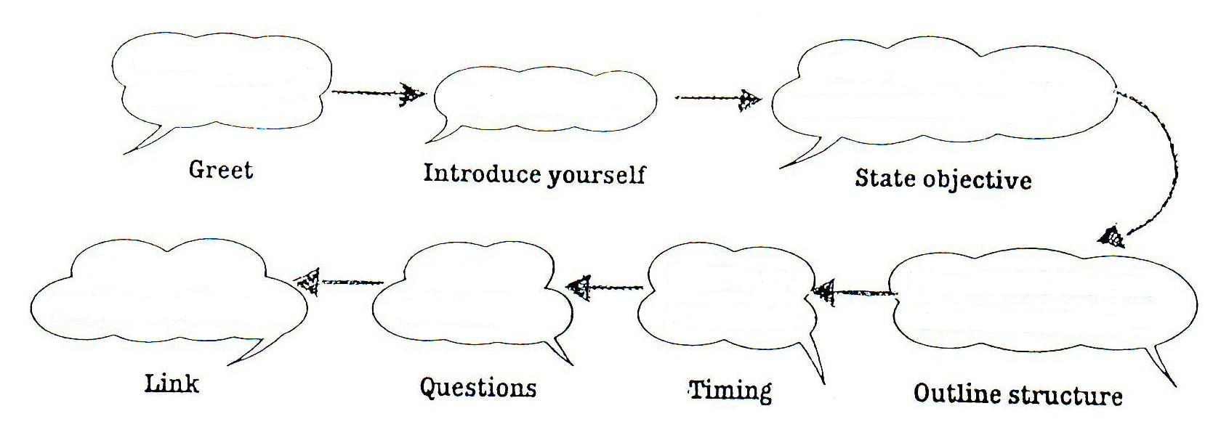
b. Main Body
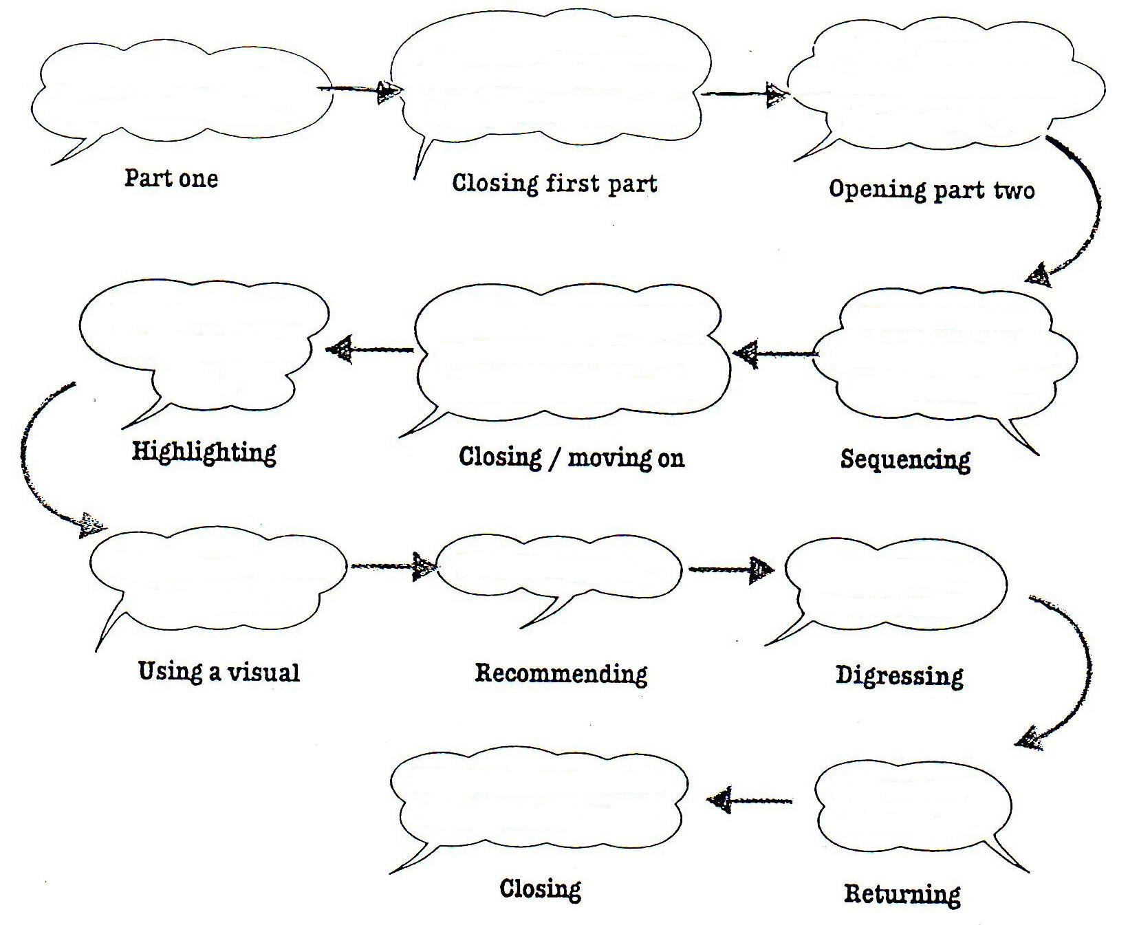
c. Ending

